Eur-Roman-Lamps-Clay

11 cm - 10 cm

NB.150.R57.9/A93-A97

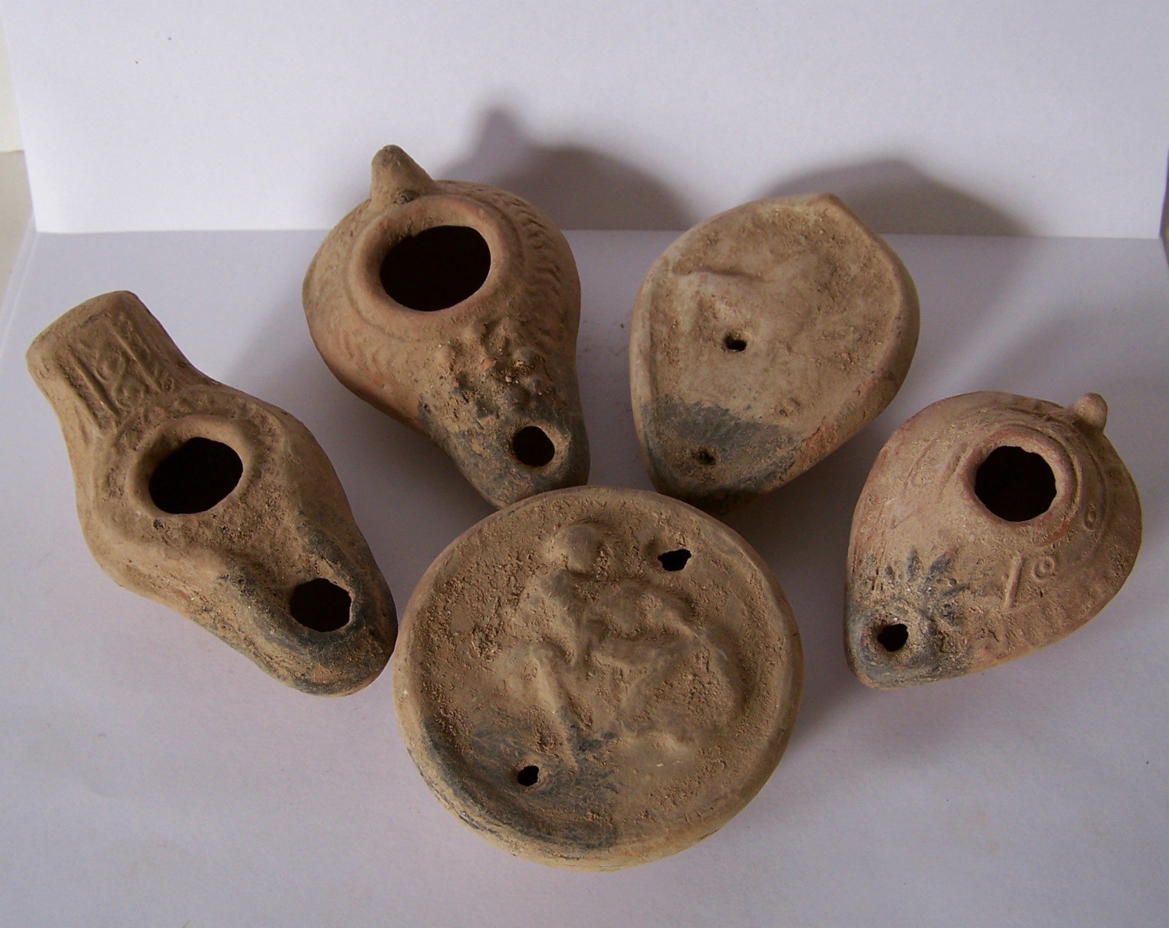

| Shipping details |
| --- |
| **Ralph J Coffman Jr**  149 Atlantic Ave  Swampscott MA 01907-2427  United States |

## Order details

|  |  |  |  |
| --- | --- | --- | --- |
| **Item title** | **Available actions** | **Shipping & handling (estimated delivery*)** | **Price** |

[Printer version](http://payments.ebay.com/ws/eBayISAPI.dll?ViewPaymentStatus&transid=0&userloginid=802-867&orderid=125303748018&printerversion=true&itemid=271104286471)

|  |  |  |
| --- | --- | --- |
| Seller: | [**Member id** antiquewd](http://myworld.ebay.com/antiquewd) ( [**Feedback Score Of** 1459](http://feedback.ebay.com/ws/eBayISAPI.dll?ViewFeedback&userid=antiquewd)) | [Contact seller](http://contact.ebay.com/ws/eBayISAPI.dll?ShowCoreAskSellerQuestion&frm=3998&iid=0&redirect=0&requested=antiquewd) |

|  |
| --- |
| **Order # 125303748018**  Paid on Nov-18-12 via PayPal |

  Price**Paid or notItem shipped or notFeedback left or notFeedback received or not**Actions**antiquewd**

[**Member id** antiquewd](http://myworld.ebay.com/antiquewd/&_trksid=p3984.m1439.l2754) | [**Feedback Score Of** 1459](http://feedback.ebay.com/ws/eBayISAPI.dll?ViewFeedback2&userid=antiquewd&_trksid=p3984.m1439.l2776) | 98.5%

**Total items :** 17

$541.62

+$40.00

shipping

**5Roman style clay oil lamp**

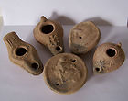

[5Roman style clay oil lamp](http://www.ebay.com/itm/360512462055?ssPageName=STRK:MEWNX:IT&_trksid=p3984.m1439.l2649) (360512462055)

Your max bid: $55.00

Sale date: 11/18/12

Tracking number: --

Estimated Delivery: 11/21/12 - 11/26/12

$55.00

**Paid with PayPal on November 18, 2012.**

**Not shipped**

**Feedback not left**

**Feedback not received**

|  |
| --- |
| [**Leave feedback**](http://feedback.ebay.com/ws/eBayISAPI.dll?LeaveFeedbackShow&useridto=antiquewd&item=360512462055&transactID=0&ssPageName=STRK:MEWNX:LF&_trksid=p3984.m1439.l2665) |
| [Sell this item](http://cgi5.ebay.com/ws/eBayISAPI.dll?SellLikeItem&item=360512462055&ssPageName=STRK:MEWNX:LILT&_trksid=p3984.m1439.l2667) |
| [More actions](javascript:;) |